Running a simple store

ocPortal provides a system of products and services that we can be purchase. By default, there are certain kinds of products available in ocPortal. They are:

- Usergroup subscription: We may configure as many usergroup subscriptions as we wish, and these are all handled by the 'Usergroup' product kind. Each configured subscription is considered as a 'product' for sale on your site.
- Catalogue items: These items can be purchased from the online store.
- Orders: These products are a collection of other products bound into a group, and generated when someone finalises an order from the shopping cart.
- Work: This is a generic kind of product used to represent something that has been invoiced.
- Various kinds of non-purchasable product that exist for accounting purpose – 'interest', 'tax', 'wage' and 'other'. These aren't for sale on your site but positive or negative transaction sums can be entered against them in the Admin Zone, so your profit/loss and cash-flow charts can be accurate.
Product kinds fit into the following general categories:

- Invoice: requests for payment created from the Admin Zone, paid from the “site:invoices” module (above: work)
- Subscription: one-off purchases made from the “site:purchase” module (above: usergroup subscriptions)
- Shopping cart: an item purchased from the site:catalogues/site:shopping modules (above: catalogue items)
- Other (above: interest, tax, wage, other)
- Purchase wizard: one-off purchases made from the site:purchase module (above: none available out-of-the-box).
Online Store
The ocPortal online store was introduced in version 4.2, and works via existing ocPortal catalogues system. The shopping cart catalogue are called 'products'. This catalogue has some hard-coded fields:
- Product title – the product title / name
- Item code – a code of your choice for the item, probably taken from your internal labeling system
- Price – the item's price (pre-tax)
- Stock level – the number in stock
- Stock level warning point – the point at which you should be e-mailed if the stock level reaches
- Whether stock is being maintained – whether you want stock control (as above)
- Tax rate – the tax rate, a percentage chosen from a list (you may edit the catalogue to change what is shown in the list)
- Weight – the items weight, in units of your choice (but all items must consistently use the same units); the weight will operate with the configuration option that specifies how much it costs to ship a unit of weight
- Description – a description for the item
The order of these fields are used internally by the system to identify what they refer to, so we cannot re-order these fields (or delete, or change the field type). We can also add additional fields like product images or specifications. After setting the fields according to our wish, then we can add categories and entries to the catalogue.
We can add a product to the catalogue just by selecting the option 'Add a Products entry' from products of content management window or through the catalogue entry. The added product will be listed in the page site:catalogue, from there we can select the item for purchase.
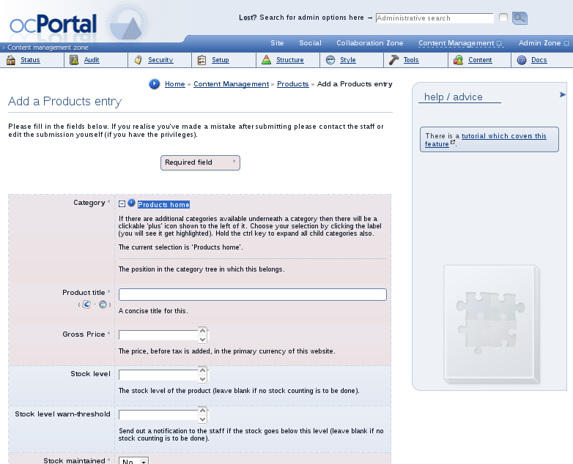
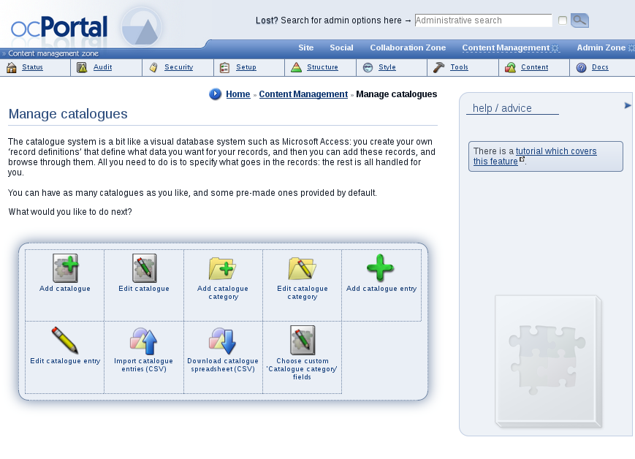
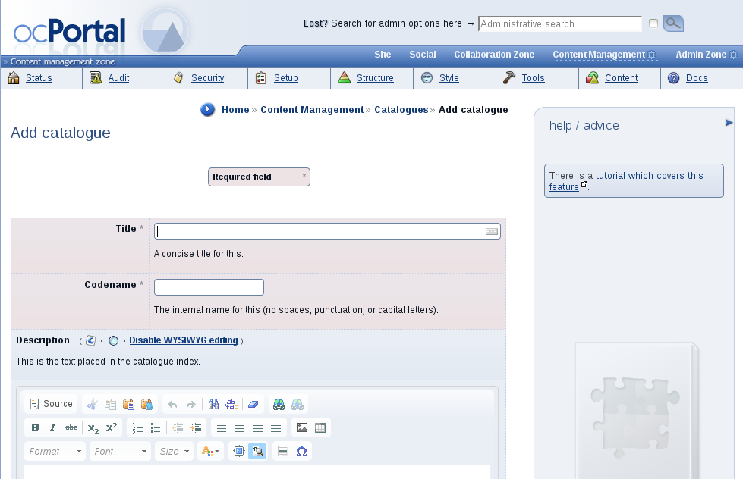
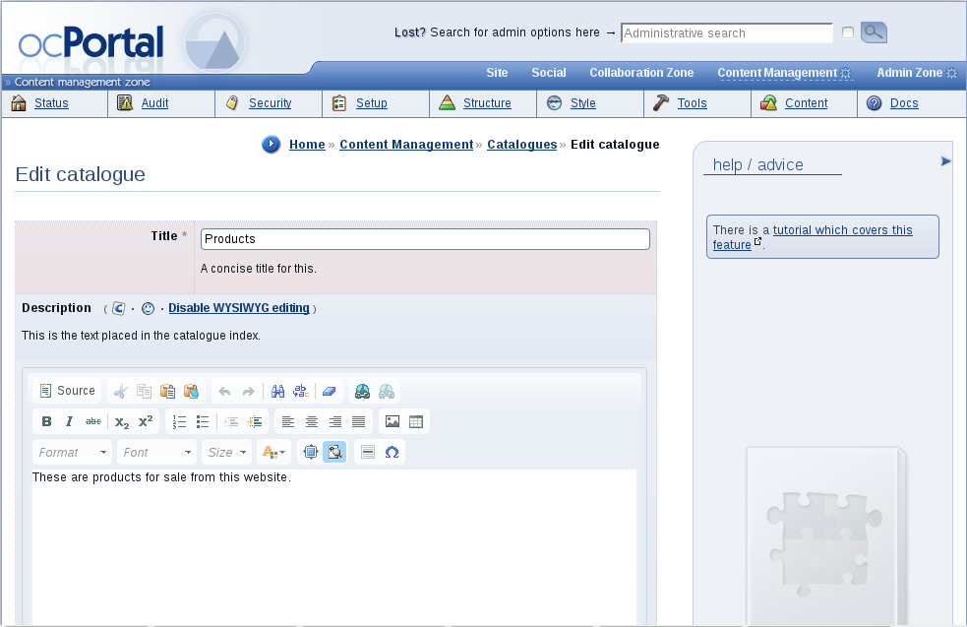
Once we have the entries and e-commerce configuration, the user can start using our store to purchase items. Point them to the catalogue to do their shopping, and from there they will be able to navigate to the shopping cart and finalize and pay for their order. The important thing to keep in mind while placing order is that once ordered, a catalogue entry shouldn't be deleted usually. So place the orders carefully. From the catalogue you can add the item to the cart, and go to the cart (site:shopping module) to finalise and then pay for your order.
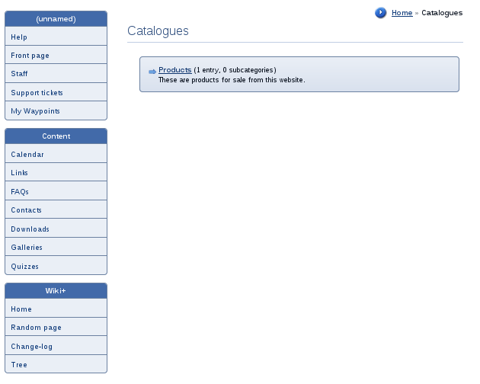
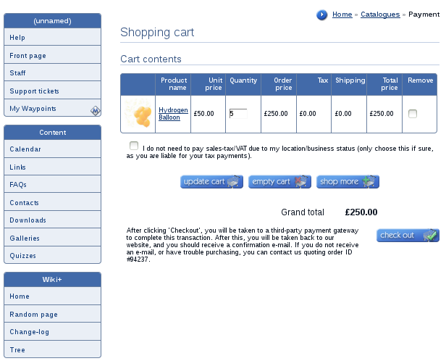
When orders are placed, an e-mail is sent out to the staff so they can fulfill the order, and the stock level is adjusted. Orders may be reviewed by the purchaser from their site:orders module. Order status can be changed (e.g. to “dispatched”) from the Admin Zone. Thus a store system can be operated simply using ocPortal.

