Setting up your Community

Ocportal provide us to set up our own community. ocPortal provides the following options for this feature,
  - Add new Zone
  - Add forum group
  - Add forums
  - Add user groups

Zone
We can create different zones for each sub community, for that we can use the Add zone option in the 'Structure » Zone' menu item in the administrator zone (Figure-1). By creating a new zone we can also set the permissions to allow certain user groups to access the new zone.

Figure-1:
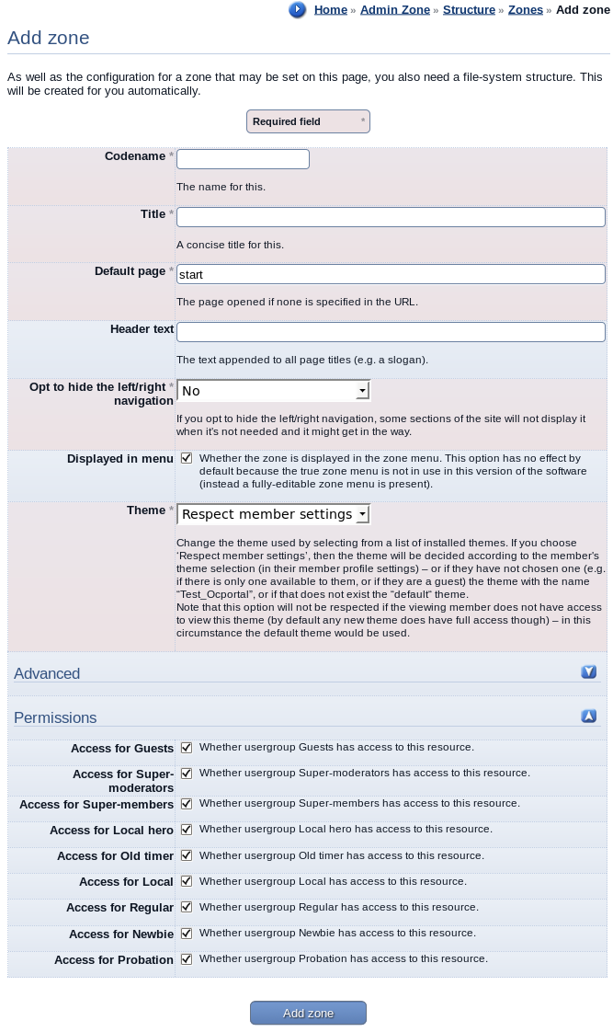

Manage Forums

Forums are a communication tool for site users. Within each forum we can create different topics and within each topic there are one or more posts. We can add/edit forums and its groupings(categories) through the 'Manage Forums' page in the admin zone. We can open that page through the menu 'Structure » Forums' in the administrator zone as shown in Figure-2.

Figure-2 :
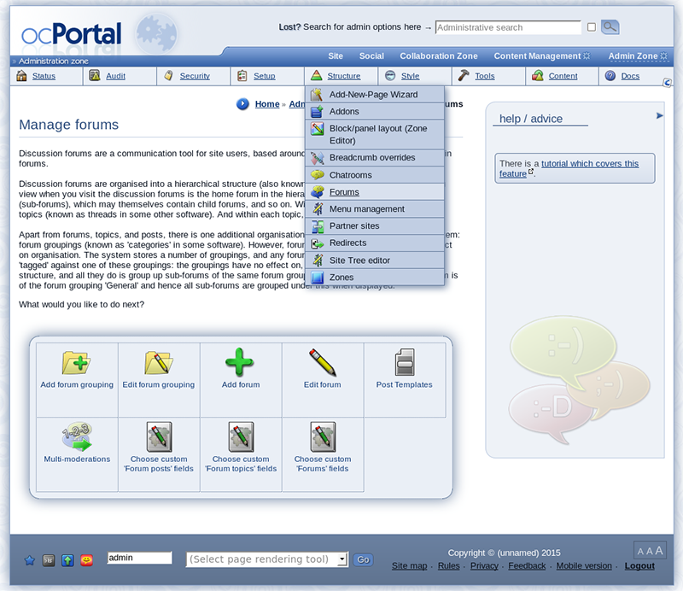

You can also see different options of 'Manage Forums' page on Figure-2. By using the 'Add forums' link we can create a new forum under the default forum grouping called 'General' . You can also set your own forum grouping by using the 'Add forum grouping' option in the 'Manage Forums' page.

Forum Groups

The forum groups are used to place a forum under a particular category. The groupings have no effect on, and are not a part of, the forum structure, and all they do is group up sub-forums of the same forum grouping visually. By default all the forums that we create belongs to a forum grouping called 'General'. We can create our own forum grouping by using the Add forum grouping form in the ocPortal as shown in Figure-3.

Figure-3 :

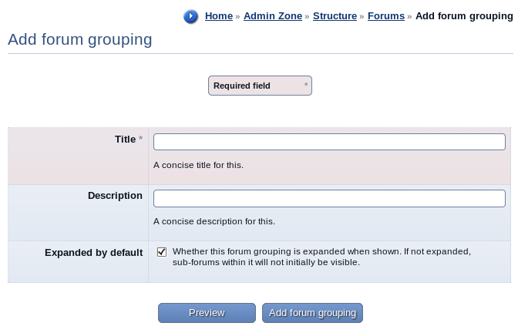

Add Forums

We can create forums by using the Add Forum form (Figure - 4.1) . In this form, we can place the forum under a forum group and can set some user permissions for using that forum.

By using the permissions section in the Add Forum form (see Figure- 4.2), we can define whether members of each user group have access to them, as well as allowing privilege overrides. We can also deny the user groups from any kind of access to certain forums to make them private.

Figure- 4.1 :

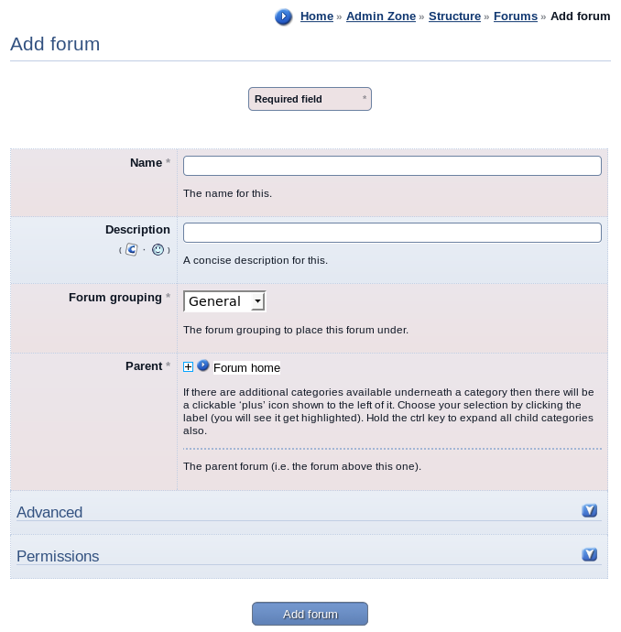

Figure – 4.2 :

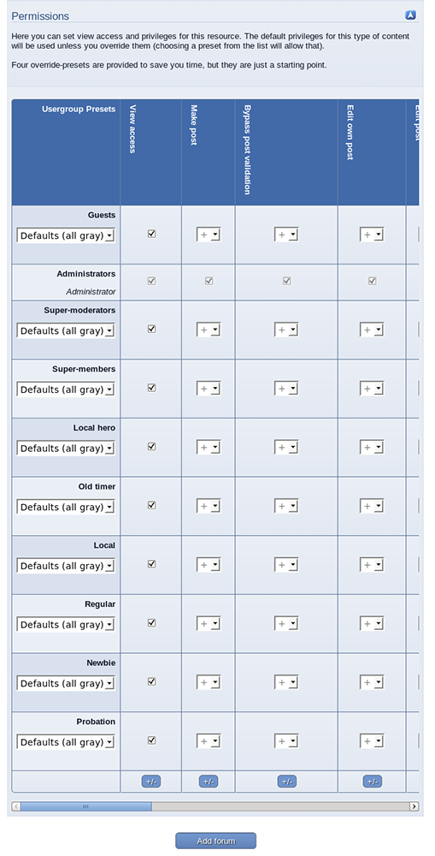

Usergroups

The members of a community can be grouped to a user group and there by assign certain permissions for that user group. We can add a user group by using the 'Add Usergroup' option in the 'Security » Usergroup' menu in the admin zone. The figure below shows the form for adding a new user group. (Figure-5).

If the newly creating user group is going to use as a primary user group then you must select one of the option from the 'Take permission from' field at the bottom of the Add user group form.
Otherwise we do not fill this field. It is recommended that you leave all non-staff members such that their primary user group, and use secondary user groups for the purpose of placing them in sub-communities, and granting additional permissions.

In the Add Usergroup form, we can set the username of the user group leader that may add and remove other members from this user group. Otherwise, only administrators may add users to the user groups.

Figure- 5 :


