Making CSS changes to ocPortal

CSS (cascading style sheet) is a language that defines how the HTML elements are to be displayed in a website page and its style. Thus CSS is responsible for the look of our site including color schemes and border styles. CSS is a simple language, consisting of rules, which contain various properties; the individual parameters for styling an element. The basic format for applying style to an HTML element is as follows.

selector
{
property: property-value;
}

The selector defines which HTML elements/classes/IDs the properties in the rule are applied to, the property is the pre-defined name of the property, and the property-value is the value assigned to the property (the allowed values vary from property to property). There are several types of selector defined by the CSS 1 standard, the most basic selector is the type selector, and it selects all the XHTML tags in the markup of the specified name. Another basic selector is the class selector, which selects all XHTML tags with the specified class attribute value. ID selectors are another basic selector type, which apply properties to elements based upon their id attribute.

Other than the normal sites ocportal has CSS split up into number of files. The HTML of pages are also split in to many pages and those are called templates. Every page of the ocportal page has its template files and the css files and this separation of these template files and css files provides re-usability.

Editing CSS files

Ocportal offers theming and we can either use the default theme provided by the company or can create new theme as our own for using in our website. The CSS files will be the part of these themes and we can edit those files from the manage theme section of the adminzone. 'Edit CSS (styles)' option of the manage theme of adminzone lead us to a page containing list of css file names. From those we have to select one those we are going to edit and then that file will be open in an editor window.
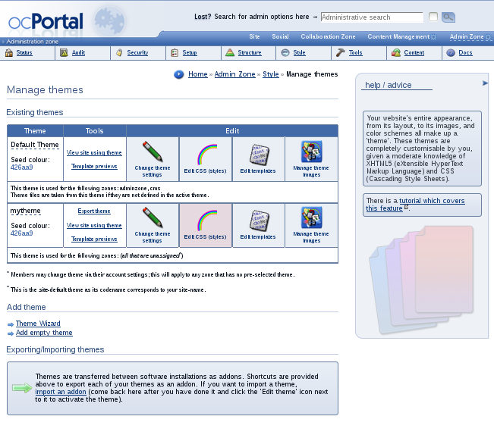

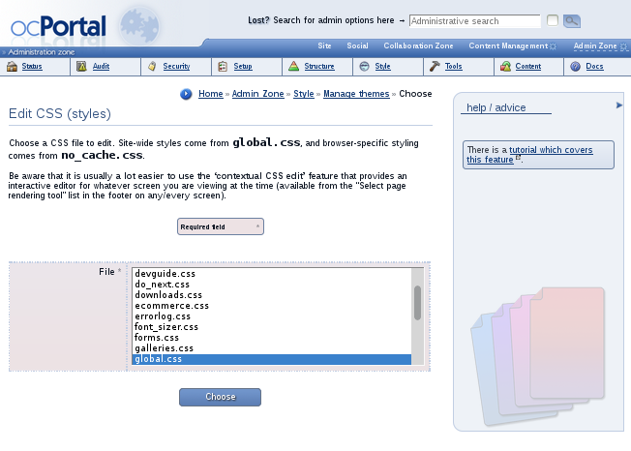

There are mainly two css files available such as global.css and no_cache.css, the site-wide styles come from global.css, and browser-specific styling comes from no_cache.css. The window that gets opened after choosing a css file contains an editor within which the file opened and the other related information about the corresponding css file. There is an option in the window that we can select the editor of the file from advanced and the normal options.
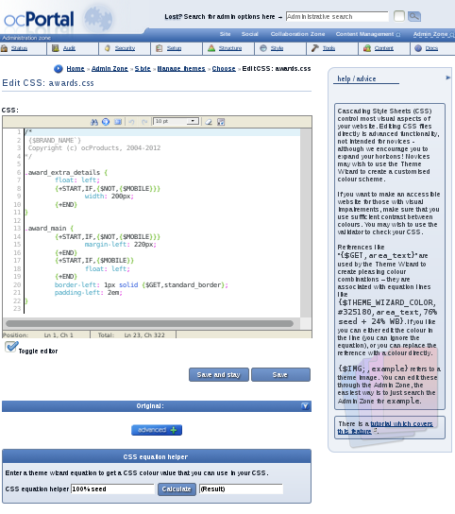
Contextual CSS edit

This is an important feature offered by ocportal for editing the css of a page, that provides an interactive editor for whatever screen you are viewing at the time. This is available from the “Select page rendering tool” list in the footer on any/every screen. From the list of css file we can select the one that we need to edit and then by clicking 'Go' button we can get it opened in a window. In the window we can see different information arranged in a friendly manner that for making the editing easy for the user. In the contextual editing window we can see a portion explaining the common CSS properties. There the properties are arranged as groups based on their application such as background properties, border properties, dimension properties etc. The CSS file which is open in the editor can modify and can save easily with the help of instruction provided. Thus contextual editing makes the CSS editing an easy task.





