Adding a complex Contact Form

Ocportal allow us to create complex contact forms using the 'main_contact_catalogues' block. For that, Ocportal supports the following features.

  - Add a Catalogue
  - Add/Edit Comcode Page
  - Add Comcode Block

We can add a contact form by using the catalogues as template. For that we can set up a catalogue and use it as a form builder for a contact form. Also we can use the default catalogues for creating a contact form.

After creating a catalogue, we can add a new page or edit an existing page for adding a contact form. The Add/Edit comcode page will allow us to add a dynamic comcode block from its editor.

By using the comcode block, we can choose the 'main_contact_catalogues' block from the Catalogue section of the block. Through this section we can set up the required contact form in a page.

Add a Catalogue

In Ocportal we can add a catalogues through the Add Catalogue option from the Manage Catalogues page through 'Content » Catalogues' menu in the admin zone as shown in Figure-1.

Figure-1 :

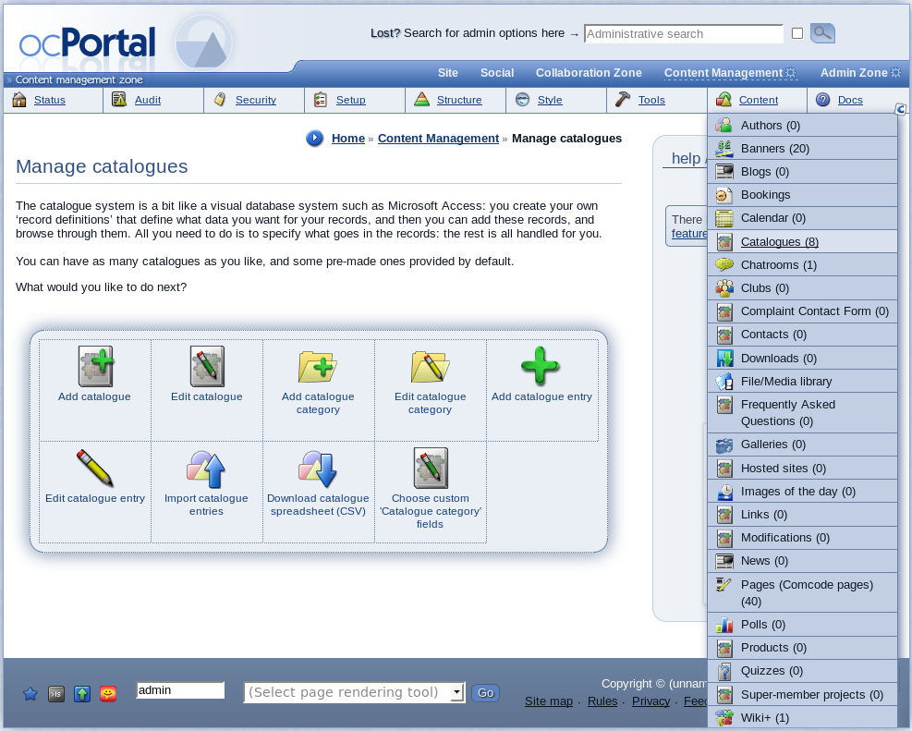

We can use the 'Add Catalogues' settings as a form builder and can add any number of input fields required for our desired contact form. After creating the catalogue the created catalogue can be used for adding the contact form in a page using a comcode block.

Add/Edit Comcode Page

We can add a contact form in a new page or an existing page. For creating a new page we can use the 'Add new page wizard' through the 'Structure » Add new page wizard' menu in the admin zone. After setting up the values for zone, codename, menu, title and language for the new page the 'Add new page wizard' will proceed to the 'Add comcode page' editor section where we can add the contact form by using the dynamic block tool in the editor(Figure-2).

Figure-2 :

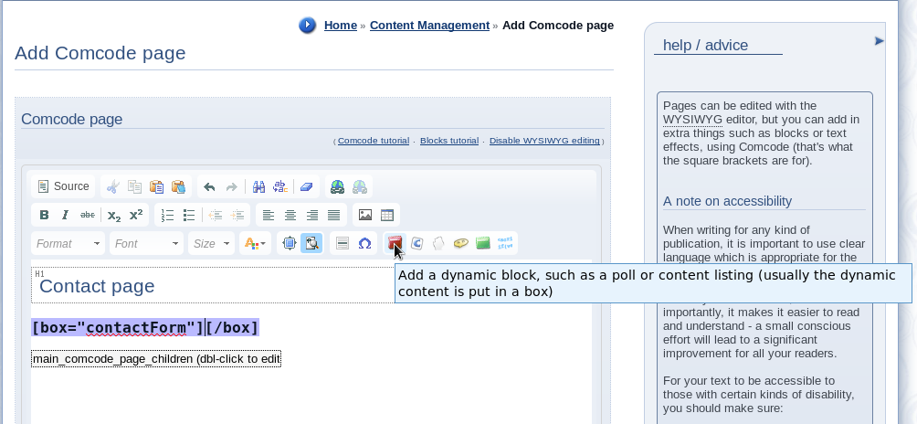

Add Comcode Block

The comcode dynamic block tool will display a 'Block construction assistant' 'pop up window that contains the settings for different types of contents. Among these blocks, choose the 'main_contact_catalogues' block in the Catalogues section as shown in Figure-3.

Figure-3 :

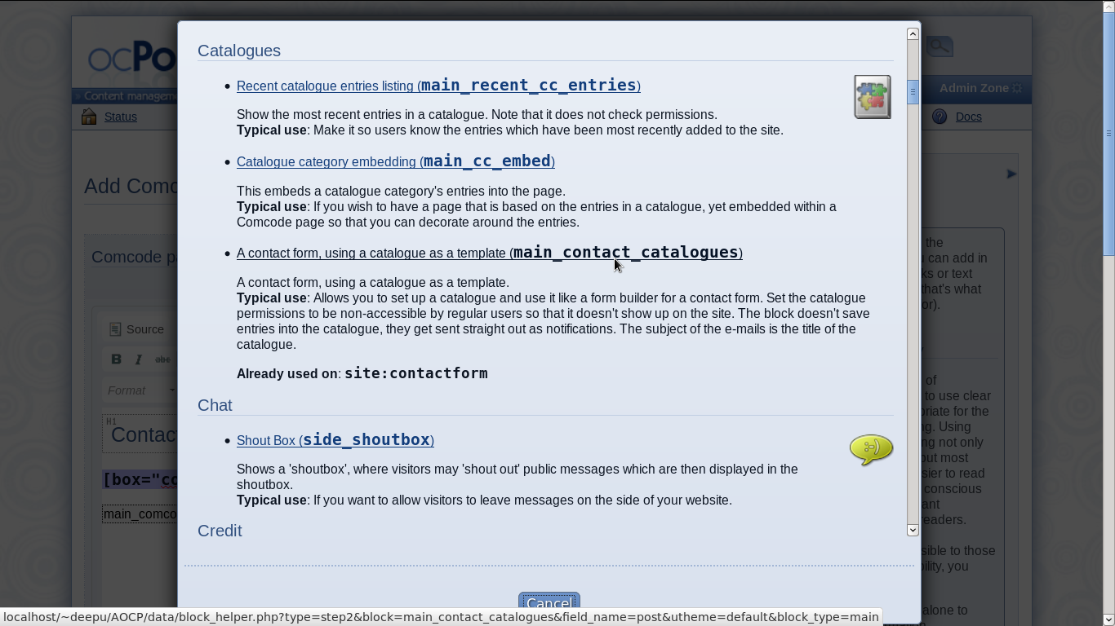

'main_contact_catalogues' block

In the 'main_contact_catalogues' block, we can set the 'To' email address in which the notifications using the contact form values are to be sent. And can set the 'Param' value used for selecting the catalogue name that we created for the contact form for using as a template (Figure-4). The 'Param' field contains the catalogue names of some default catalogues and the ones that we created. We can select the required catalogue name from the drop down list otherwise the deafult value will be used.

Figure-4 :

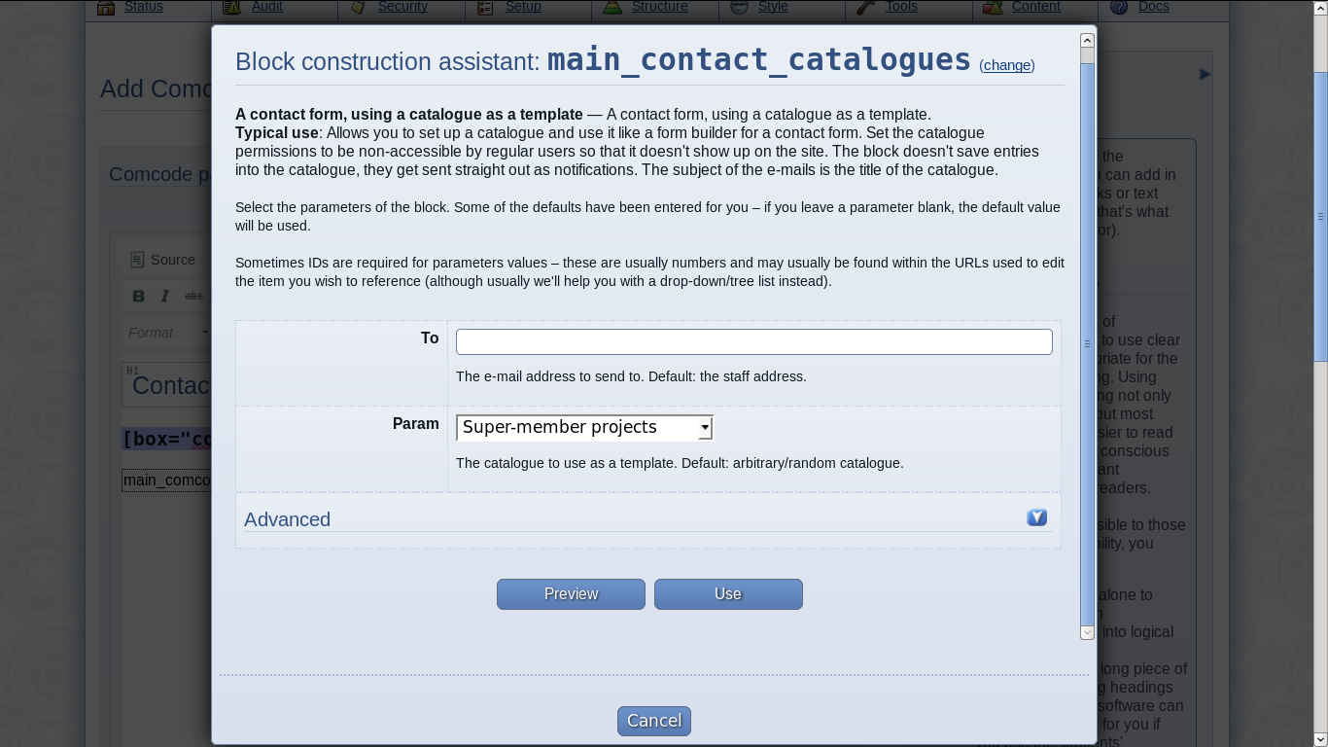

After adding the 'main_contact_catalogues' block in the comcode page, we can create the page and the page will display the contact form with the input fields which are created through catalogues and the contact form will send the values of these input fields to the given email address as a notification.

---------------------------------

