Ranks

OCF is a powerful forum or a member system that comes up with ocPortal. In OCF there is a ponts system available for encouraging the participation of members in the forum. The member who is joining in to the ocPortal site or forum will be assigned in a user group and each group has there own permission for accessing the site. This usergroup system allows automated progression from one usergroup to another, according to point count. There are many ways to earn points in ocPortal and are calculated dynamically according to various statitics. The methods of earning points include:
- Joining
- Voting in a poll
- Rating content
- IOTD chosen
- Poll chosen
- Submitting various forms of content
- Length of membership
- Visiting the site
- Posting on the forum
- Entering/passing quizzes
- Being given them (this is described in a later section)
- Earning them from selling a download (this is described in a later section)
- Earning them in the ocWorld addon (this is described in a later section)
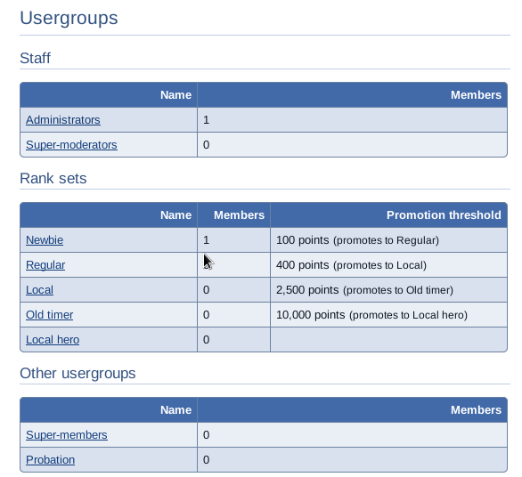
According to the points earned by the member the usergroups in which the member belongs to
will change automatically. Each usergroup has there own rank and at the time of joining a member will assign in a group having lowest rank. And as the participation of the member increases the points accured will also get increases and thus the member will progress to the new groups with higher ranks. This is configured by default such that the usergroup rank images for the usergroups involved imply a rising rank. The 'status symbol' of rank is an incentive for members to earn points (hence contributing to the site and community), but permissions may also be configured such as to give permission according to rank, simply by assigning the permissions differently for different usergroups. The points that we got is visible in detail in our profile, that is the action for which we got the points like that.


