Adding an Award in ocPortal Site

Ocportal provides many content featuring systems, which helps us to add some features to the site contents. This type of featuring of contents will give our site a fresh and active feeling. Ocportal have a number of content featuring system namely,

- the award system
  - award holder display
  - randomisation display
  - content display
- image of the day
- random quotes
- pollas
- flagrant text

The awards system, will help us to select a content of the site for featuring. And it provides us the advantages like,
- gives our site a fresh and active feeling
- helps us to keep our site different always
- users will regularly visit the site for new fetaured content update, so can draw their attention easily
- helps users to put their document in a prime position and thus can attain rewards.
The only disadvantage of this system is the effort that is needed to take for maintaining it because it needs regular check to the admin zone.

We can create new awards from the adminzone, in the admin zone we have a 'Setup' menu, there we can see an option 'Awards' as seen in the Figure 1. When we add new award in the site by linking with any of the content type that ocportal supports, then doing any modification to the site content, that we linked with the award, will have an option to assign that award to the content.

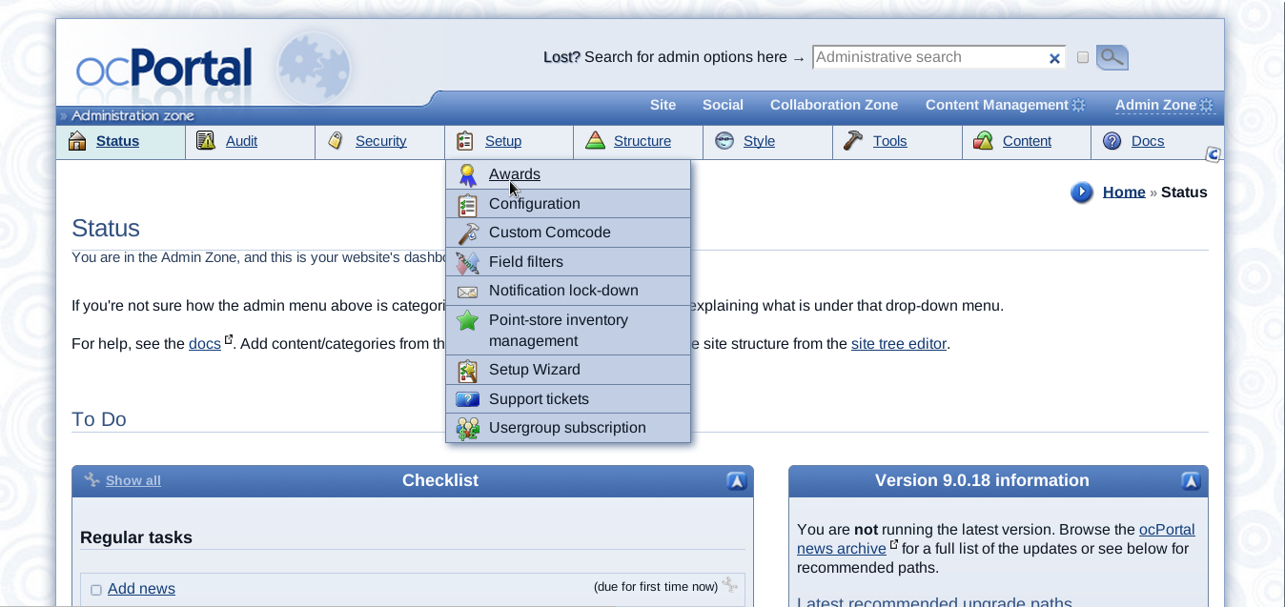
Figure1

The 'Award' option will open a page having two options namely 'add award type' and 'edit award type' as shown below. Consider the case of adding new award for the best image of the week in the site, for which we have to select 'add award type' as mentioned above.

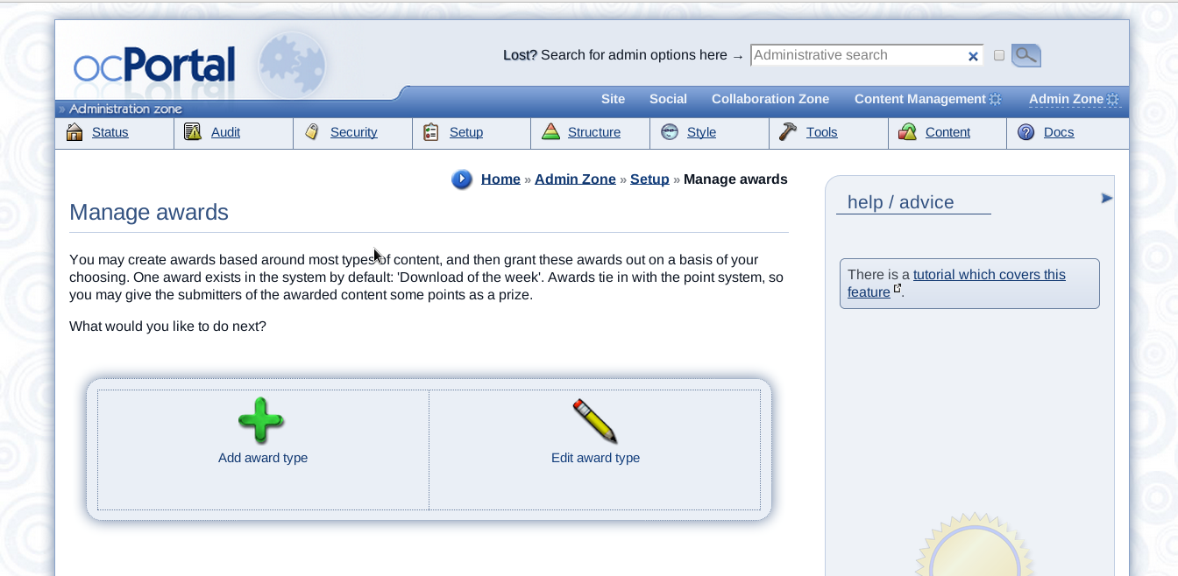
The 'Add award type' option leads us to a form containing the fields for giving details of the newly adding award type and there we have a field to link it with any of the content type that the ocportal have. And here in our example award will be assigned in weekly manner so set the update time in hours for one week. OcPortal provides different type of contents and we can use these award system with all of these contents. The available ocPortal content types are as follows,

- authors
- calendar events
- catalogues
- catalogue categories
- catalogue entries
- Wiki+ pages
- Wiki+ posts
- comcode pages
- downloads
- download categories
- forum posts
- forum topics
- forums
- galleries
- images
- members
- news
- quizzes
- usergroups
- videos

When we add a new award linked with any of the content type that is listed above, adding or editing an item of that content type will have an option to assign award to it as current holder. Normally awards are tied in with the point system, so we can add some points as prize to the submitters of the awarded content. The 'Edit award type' will allow us to edit the already added awards.

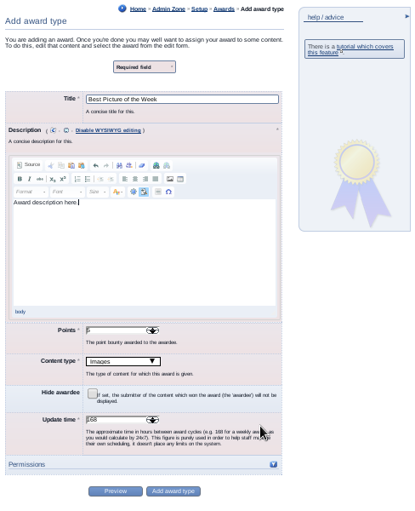

Placing a block at front page to hold created awards

We can place the awards in to the front page of the site and it will be an easy process. The 'Block construction assistant' will help you to do that easily, the comcode page editor screen contains an 'Add dynamic block' button and that will help you to access the block construction assistant. There are different options for selecting the content of the added new block, in that you can see 'Awards' as an option. In the awards option itself you can see again three options namely,

- Content display (main_content):
- Award display (main_awards):
- Content display (multiple items together) (main_multi_content):

The 'Award display' option will lead you to the page containing the list of awards that are added along with the default one, 'Download of the Week'. There you can select the ID of the award type that you need to display at the front page.

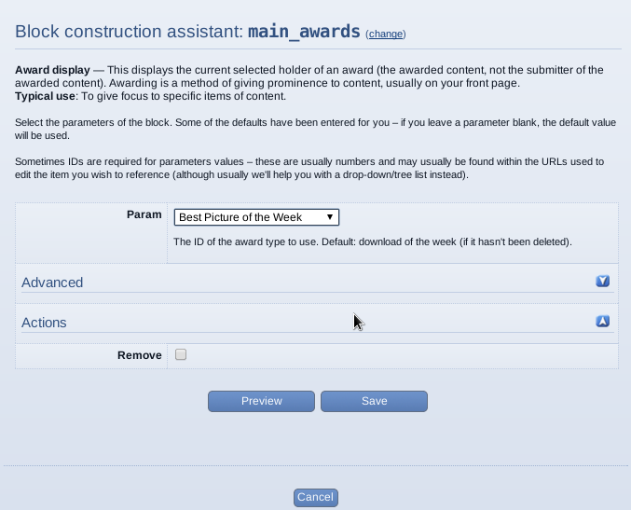

Assigning award to some content

If we create a new award type linked with a content type, then adding new data of that content type will be have an option of assigning award to that. Thus we can assign the content as the current holder of the award just by checking the box provided. Our 'Best Picture of the Week' award is added by linking with the content type 'Images' , so adding a new image will have an option to assign that as a current holder of the award.

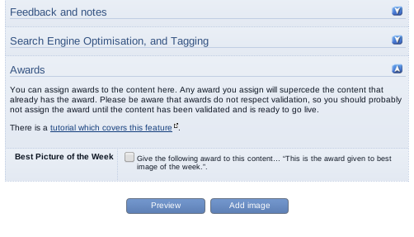
After assigning the created award to a content we can view that in the page where we placed that. And for viewing the award archive we just need to click on the 'Archive' link shown below the award as shown in the figure.



