Admin Zone Search

Ocportal supports a powerful admin zone search facility to find the various types of contents in ocportal. You can use the Admin zone search facility with the search box at the top right of your website admin zone if you have only a vague idea of what you are looking for.(Figure-1)

Figure-1 :
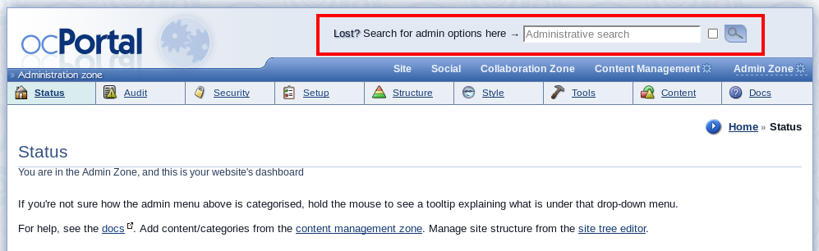

Advantages of using the Admin Zone Search

  - Typing a search keyword or snippet of text in the search box, clicking the search button, and then looking for various sections of result makes it easy to find the required search content in ocPortal.

  - The Admin zone search result page will be in a categorized manner. That means the search keyword found under each category will display as separate sections in the search result page and that makes it easy to find the exact search result. For example : the search results for the search keyword 'footer' will be in different sections such as Configuration, Option groups, Language, Templates etc...(Figure-2)

Figure -2

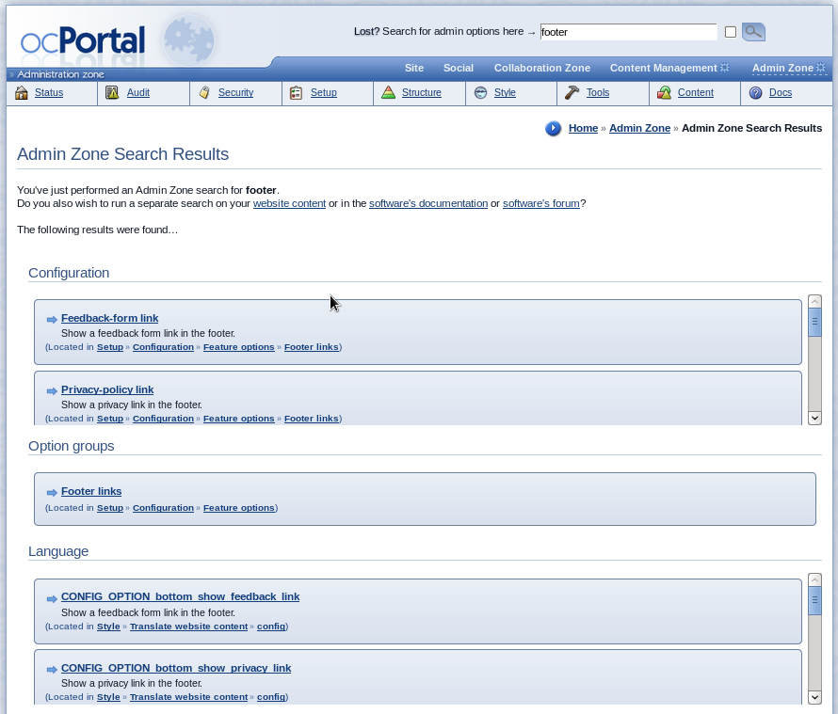

  - You can also restricts the search results to only show the results under a particular section by adding the keyword “ @sectionname” to the end of your search item in the search box. For example, if you want to search the footer settings under the configuration section only then you can use the text “footer @conf” as search keyword in the search box. (Figure-3)

Figure- 3 :

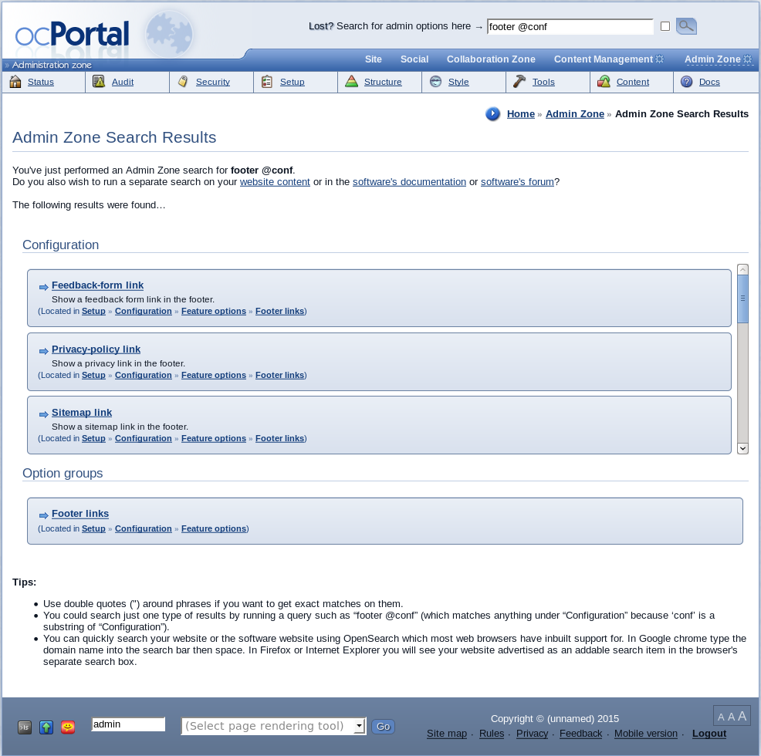

  - The Admin zone search result page also allows you to run a separate search for the same search keyword on your website content, ocPortal documentation and the ocPortal forum by giving links to the corresponding pages.(Figure-4)

Figure-4 :





